PRODUCT GUIDE
Gmail automatic reply (out of office)
How to set the Out of Office status in Gmail

PREPARED BY  People Ops | DATE  28/07/26
VERSION  1.0 | GUIDE  Gmail automatic reply (out of office)
Confidential · folge.io

Table of contents
1. Click here
2. Open the Settings menu
3. Open the full settings page
4. Turn the Vacation responder on
5. Set your last day (optional, but recommended)
6. Write a clear subject line
7. Write your auto-reply message
8. Optionally limit who receives the reply
9. Save your changes
10. You're all set

1. Click here

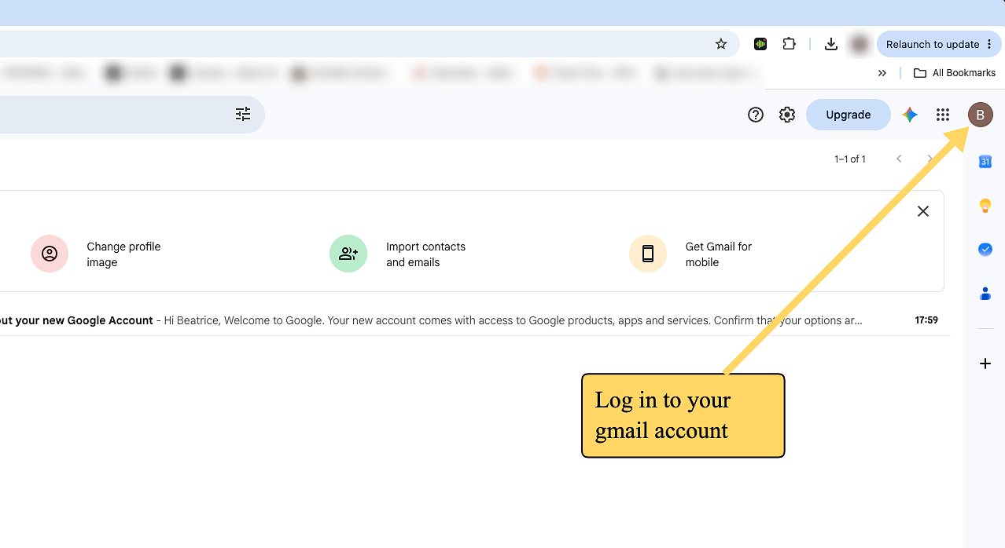

2. Open the Settings menu

ℹ️ Difference in the mobile app experience
To set up an out-of-office auto-reply in the Gmail mobile app, open the app, tap the Menu icon (three lines) in the top left corner, and go to Settings. Tap your email address, select Vacation responder, toggle it On, and fill out your dates, subject, and message.

Click the gear icon (⚙) in the top-right corner of Gmail to open the quick settings panel.

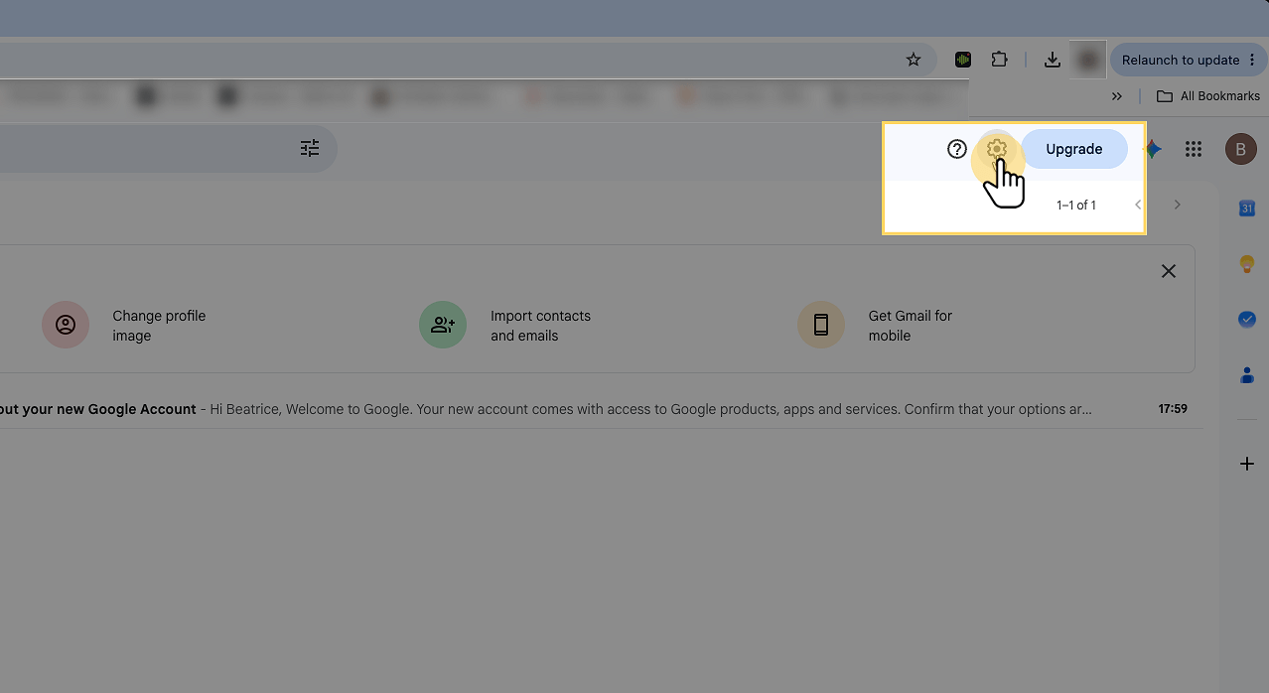

3. Open the full settings page
At the top of the quick settings panel, click See all settings. This opens Gmail's complete settings page, where the vacation responder lives.

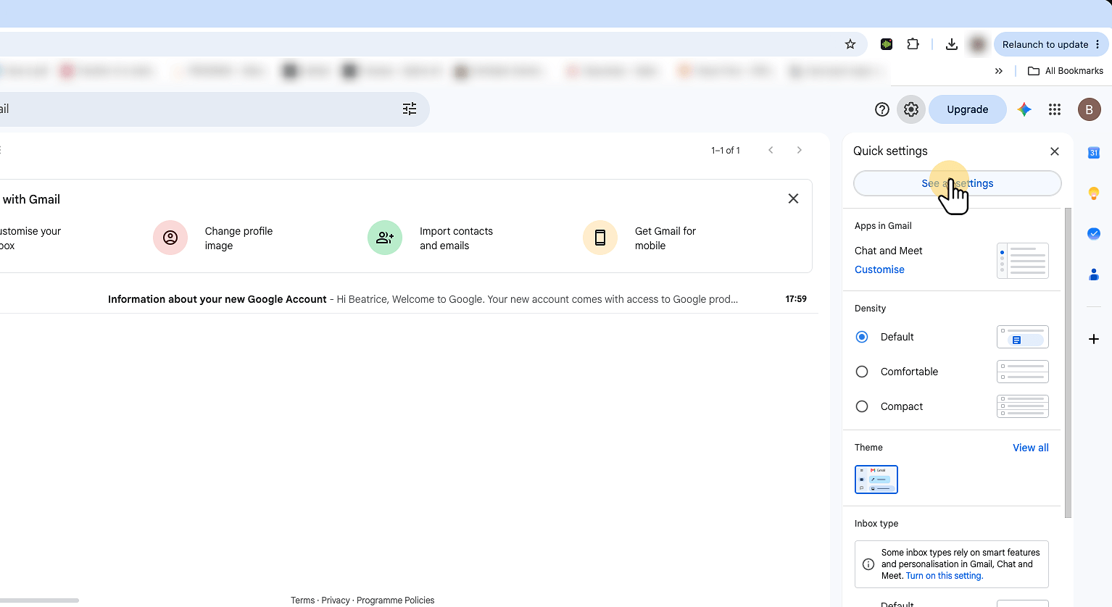

4. Turn the Vacation responder on

It's easy to get lost in all the settings..
The General tab is selected by default. Scroll all the way to the bottom — the Vacation responder section is the last one on this page.

Select Vacation responder on (Out of Office AutoReply on). The fields below will activate so you can fill in the details. The First day will fill in automatically. Gmail will start sending auto-replies at midnight on this date.

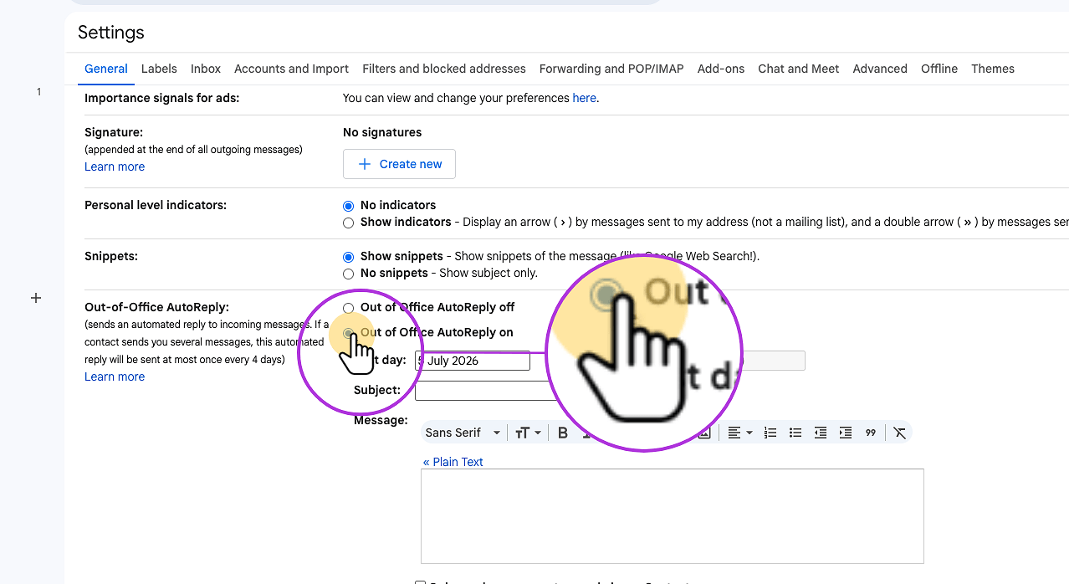

5. Set your last day (optional, but recommended)
Tick the Last day checkbox and choose your return date. Gmail will turn the responder off automatically — no risk of leaving it on after you're back. You may as well leave the field empty, just don't forget to set the Vacation responder to off upon your return.

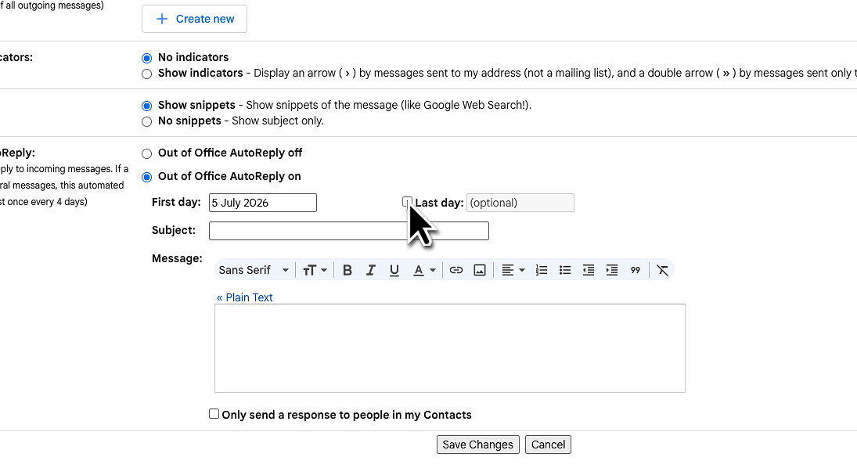

6. Write a clear subject line
Keep it short and direct — something like "Out of office — back [date]". Senders see this in their inbox immediately and know exactly what's going on.

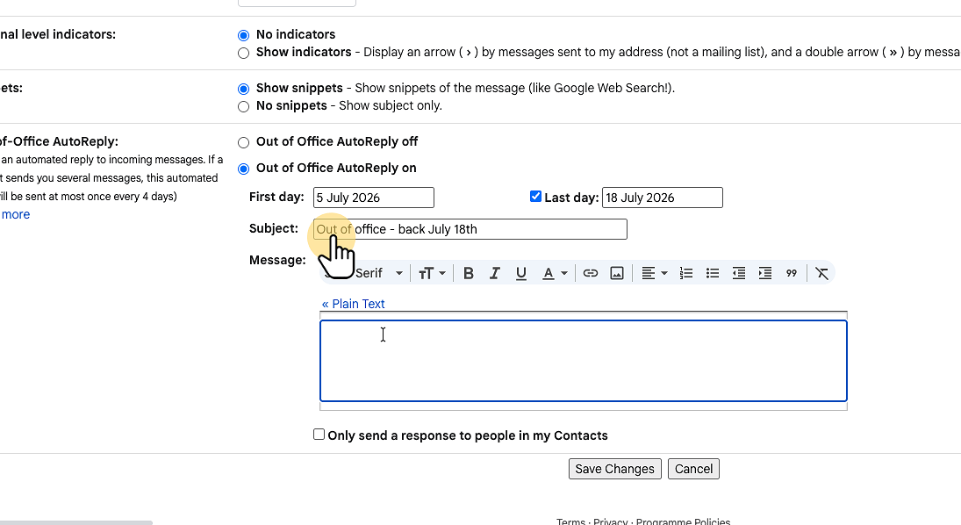

7. Write your auto-reply message
Let people know when you'll be back and who to contact in the meantime. Two or three sentences is plenty. You can use the toolbar to add formatting, links, or your signature.

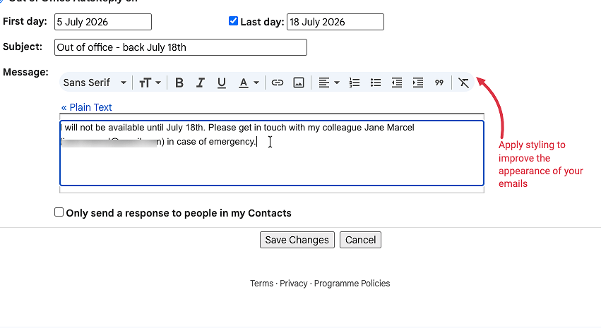

8. Optionally limit who receives the reply
Two checkboxes let you restrict the responder to people in your contacts, or to people inside your company. Use these to keep your auto-reply from going to mailing lists and newsletters.

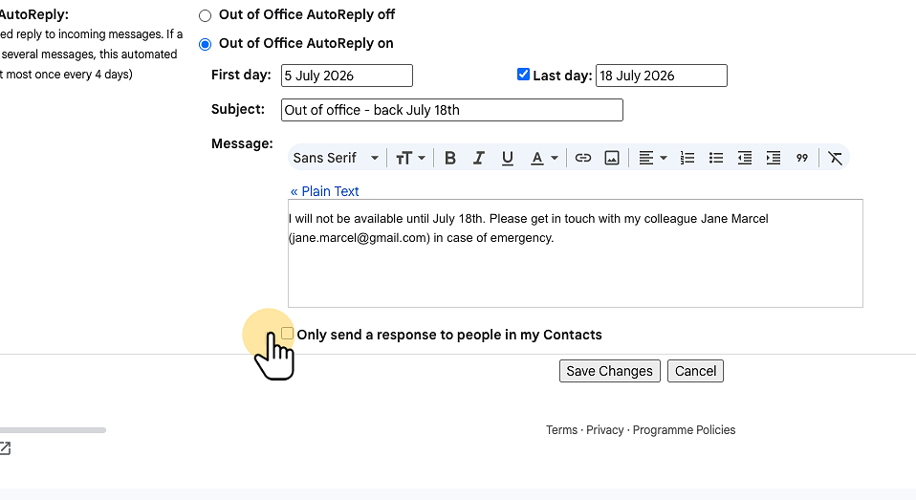

9. Save your changes
Scroll to the bottom of the settings page and click Save Changes. Your Vacation responder is now active and will start on your chosen first day.

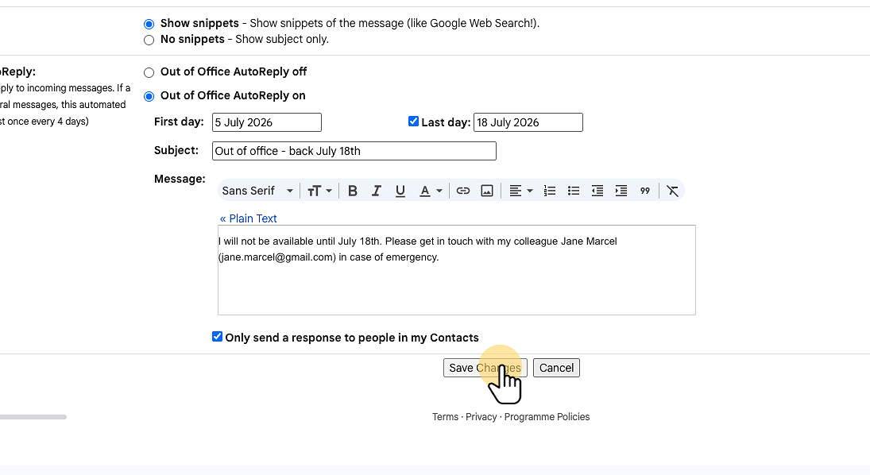

10. You're all set
While the responder is active, Gmail shows a yellow banner at the top of your inbox with an End now button. Click it anytime to turn the auto-reply off before your end date.

