Checkout flow
This guide demonstrates the checkout flow for the beautifully built form

1. Checkout overview
This is the general screen. Payments are supported by Stripe

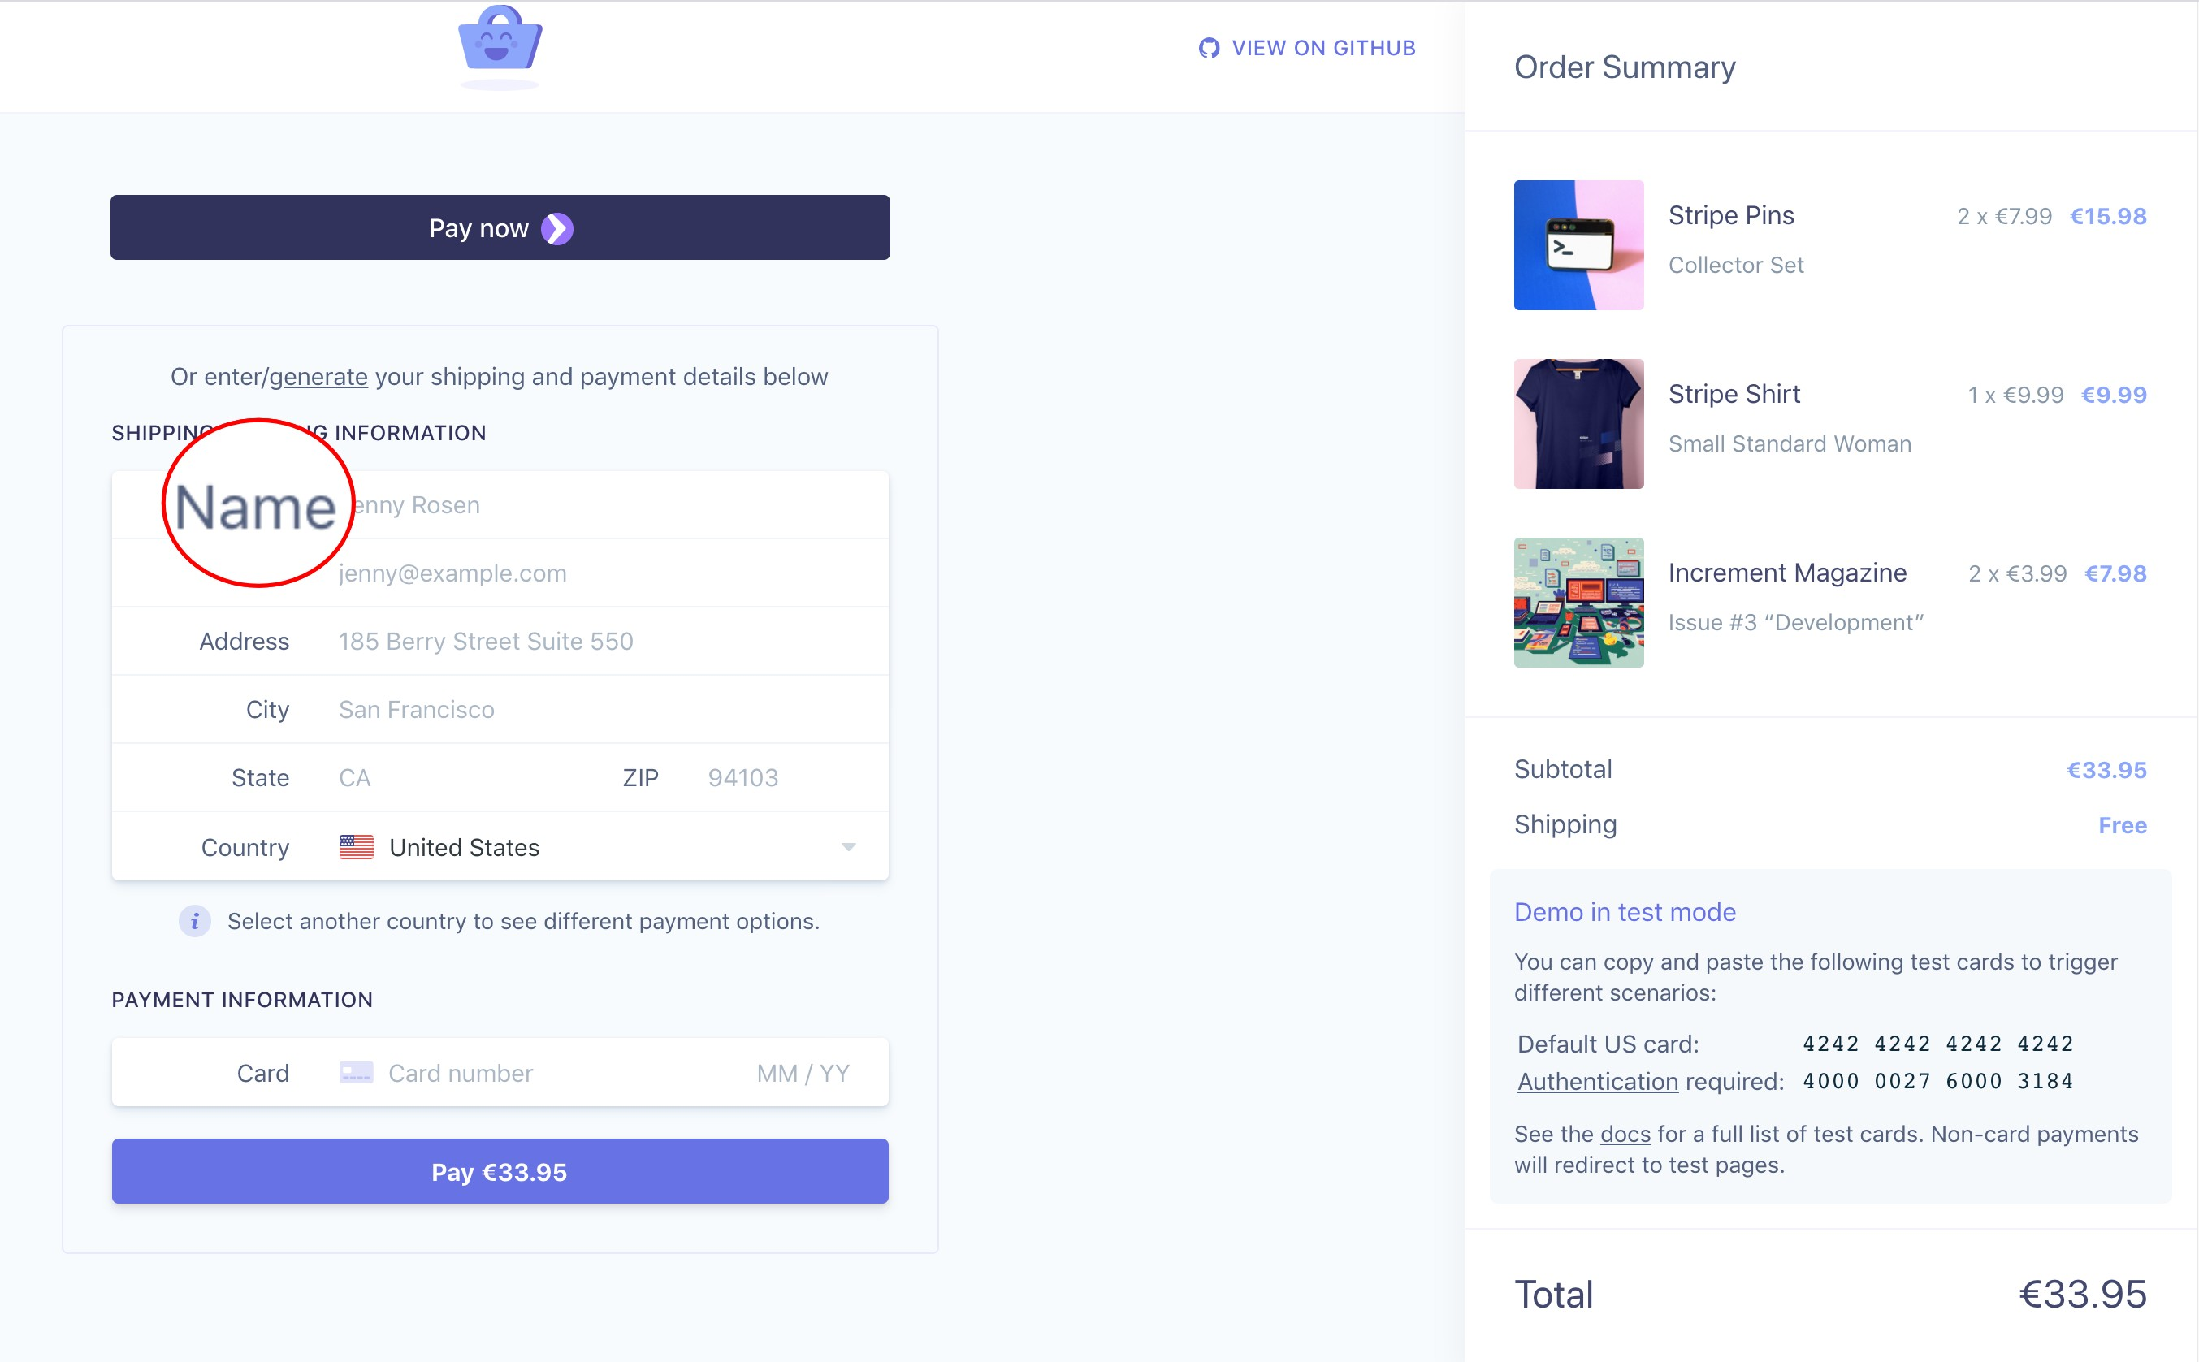

2. Order Summary
User can see their shopping basket right here

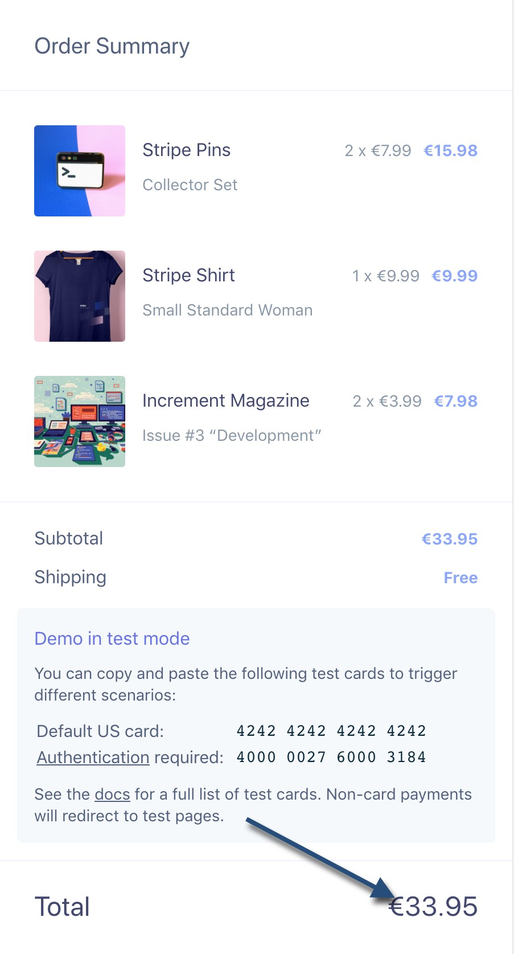

2.1. Billing form
Enter following details:
Your name
Your email
Shipping address
City
State and zip code
Select shipping country
After entering card number click Pay button

